Video recordings on SQL Labs: https://drive.google.com/drive/folders/1rFz_V3YxIsxE5qrGnIsxpxaTh8bAw8lB?usp=sharing

SQL Commands
Relational databases
SQL queries
SQL filters
SQL joins
Databases
Relational databases in tables. Multiple table
Key
Primary key – unique. One in a table
Foreign key-a column in a table that is a primary key in another table. Dublicate, allows connections to another table together.
Query
A query is a request for data from a database table or a combination of tables.
Applicable in logs analysis.
SQL vs Linux

Purpose
Linux filters data in the context of files and directories on a computer system. It’s used for tasks like searching for specific files, manipulating file permissions, or managing processes.
SQL is used to filter data within a database management system. It’s used for querying and manipulating data stored in tables and retrieving specific information based on defined criteria.

Syntax
Linux uses various commands and command-line options specific to each filtering tool. Syntax varies depending on the tool and purpose. Some examples of Linux commands are find, sed, cut, e grep
SQL uses the Structured Query Language (SQL), a standardized language with specific keywords and clauses for filtering data across different SQL databases. Some examples of SQL keywords and clauses are WHERE, SELECT, JOIN

Structure
SQL offers a lot more structure than Linux, which is more free-form and not as tidy.
For example, if you wanted to access a log of employee log-in attempts, SQL would have each record separated into columns. Linux would print the data as a line of text without this organization. As a result, selecting a specific column to analyze would be easier and more efficient in SQL.
In terms of structure, SQL provides results that are more easily readable and that can be adjusted more quickly than when using Linux.

Joining tables
Some security-related decisions require information from different tables. SQL allows the analyst to join multiple tables together when returning data. Linux doesn’t have that same functionality; it doesn’t allow data to be connected to other information on your computer. This is more restrictive for an analyst going through security logs.

Best uses
As a security analyst, it’s important to understand when you can use which tool. Although SQL has a more organized structure and allows you to join tables, this doesn’t mean that there aren’t situations that would require you to filter data in Linux.
A lot of data used in cybersecurity will be stored in a database format that works with SQL. However, other logs might be in a format that is not compatible with SQL. For instance, if the data is stored in a text file, you cannot search through it with SQL. In those cases, it is useful to know how to filter in Linux.
Query
Select and From: not case sensitive
, - for separation
; - at the end of the statement
EG:
select employee_ID, device_ID
from employees;
SQL – not case sensitive
* - select all eg: SELECT *
From employee; where * = select all
Querry a Database
Select From
SELECT customerid, city, country
FROM customers;

Order by
SELECT customerid, city, country
FROM customers
ORDER BY city;

Sorting based on multiple columns
You can also choose multiple columns to order by. For example, you might first choose the country and then the city column. SQL then sorts the output by country, and for rows with the same country, it sorts them based on city.
SELECT customerid, city, country
FROM customers
ORDER BY country, city;

Sorting in descending order
SELECT customerid, city, country
FROM customers
ORDER BY city DESC;

Lab Practice:
Codes

SELECT *
FROM machines;

SELECT device_id, email_client
FROM machines;

SELECT device_id, operating_system, OS_patch_date
FROM machines;

SELECT event_id, country
FROM log_in_attempts;

SELECT username, login_date, login_time
FROM log_in_attempts;

SELECT *
FROM log_in_attempts;

SELECT *
FROM log_in_attempts
ORDER BY login_date;

SELECT *
FROM log_in_attempts
ORDER BY login_date, login_time;

…………

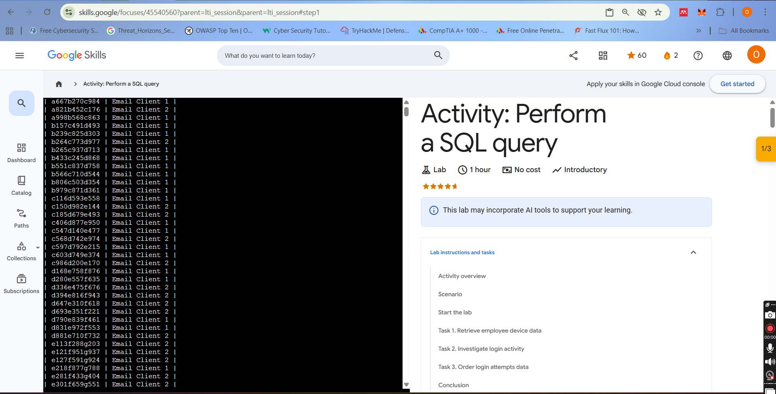
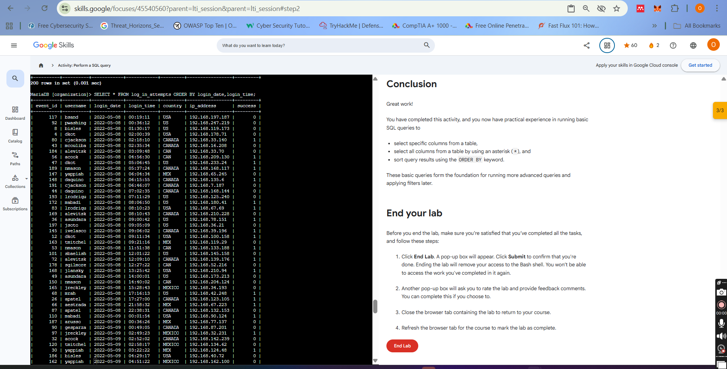

Filtering
Where = eqial sign is used for filtering.
SELECT *
FROM log_in_attempts
WHERE country = ‘USA’;
#For pattern. %, used together with the word LIKE instead of = sign
SELECT *
FROM log_in_attempts
WHERE country LIKE ‘US%’;

Filtering for patterns
You can also filter based on a pattern. For example, you can identify entries that start or end with a certain character or characters. Filtering for a pattern requires incorporating two more elements into your WHERE clause:
- a wildcard
- the LIKE operator

Wildcards
A wildcard is a special character that can be substituted with any other character. Two of the most useful wildcards are the percentage sign (%) and the underscore (_):
- The percentage sign substitutes for any number of other characters.
- The underscore symbol only substitutes for one other character.
These wildcards can be placed after a string, before a string, or in both locations depending on the pattern you’re filtering for.
The following table includes these wildcards applied to the string 'a' and examples of what each pattern would return.
Pattern | Results that could be returned
'a%' | apple123, art, a
'a_' | as, an, a7
'a__' | ant, add, a1c
'%a' | pizza, Z6ra, a
'_a' | ma, 1a, Ha
'%a%' | Again, back, a
'_a_' | Car, ban, ea7

Practical
Code
SELECT device_id, operating_system
FROM machines;

SELECT device_id, operating_system
FROM machines
WHERE operating_system = 'OS 2';

SELECT *
FROM employees
WHERE department = 'Finance';

SELECT *
FROM employees
WHERE department = 'Sales';

SELECT *
FROM employees
WHERE office = 'South-109';

SELECT *
FROM employees
WHERE office LIKE 'South%';

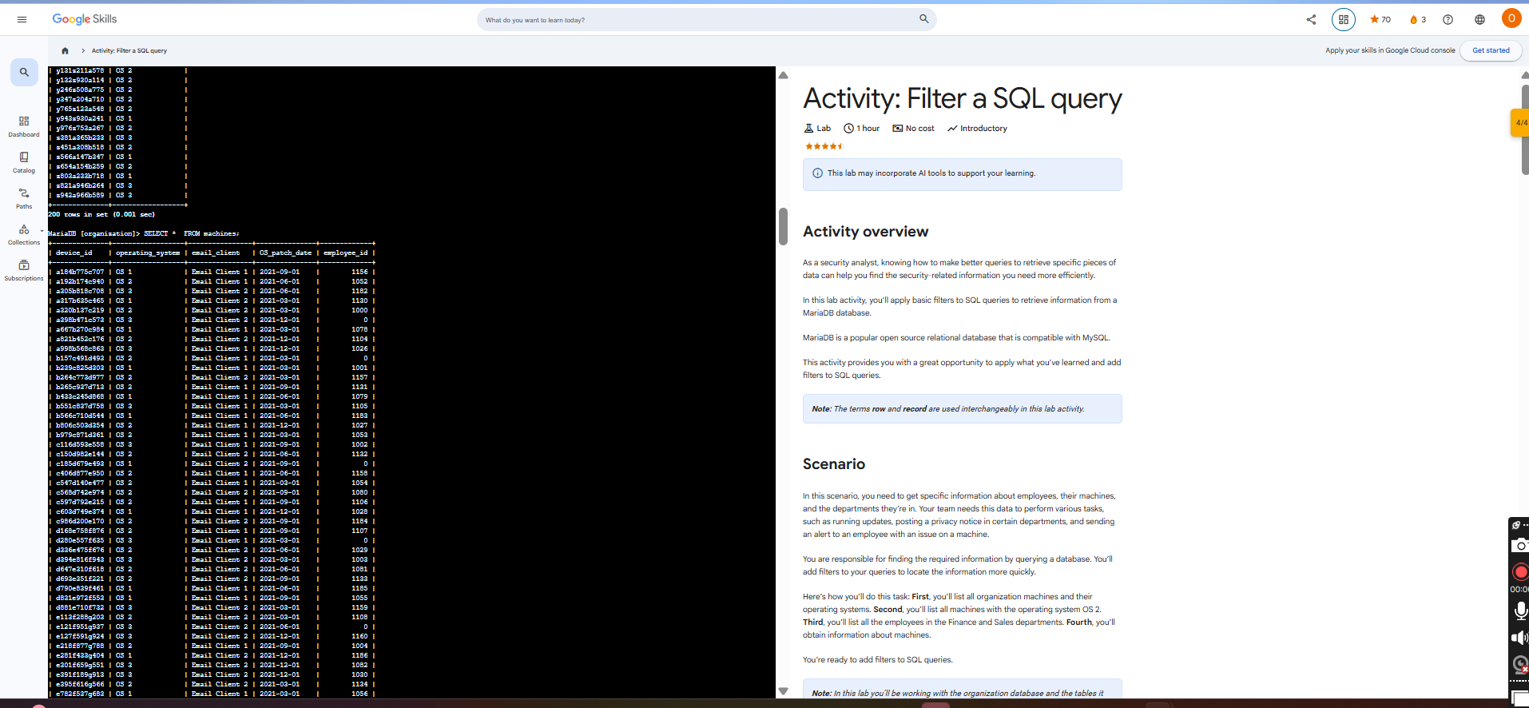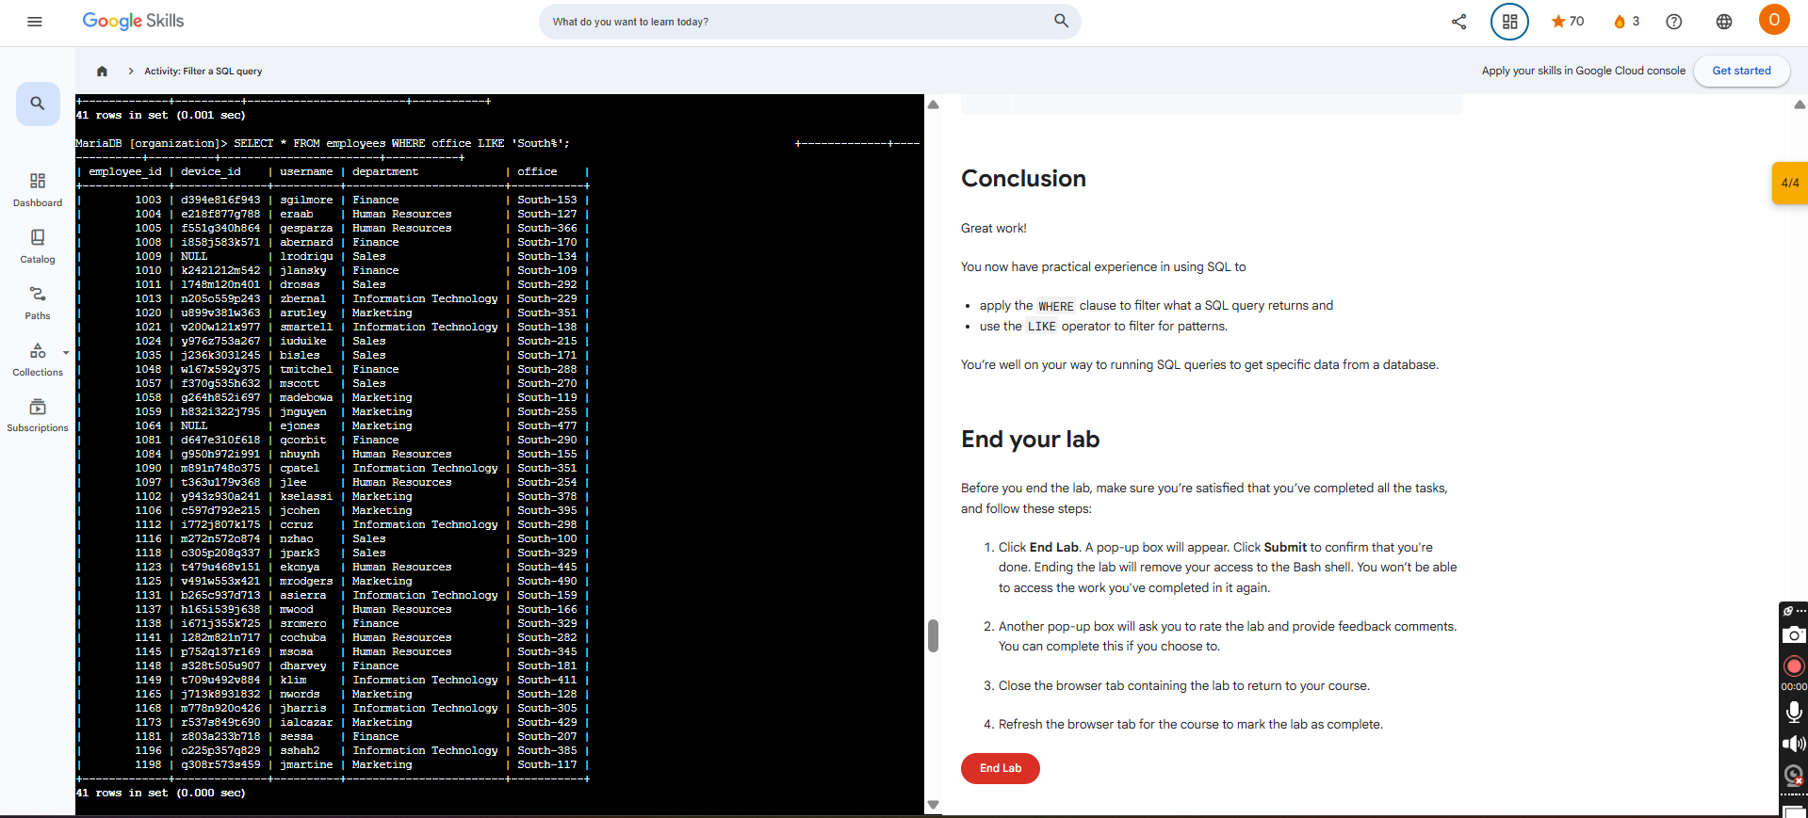

Filters on numeric and date and time data:

Comparison operators
In SQL, filtering numeric and date and time data often involves operators. You can use the following operators in your filters to make sure you return only the rows you need:
operator | use
< | less than
> | greater than
= | equal to
<= | less than or equal to
>= | greater than or equal to
<> | not equal to
Note: You can also use != as an alternative operator for not equal to.
NOTE: for date and time, use quotation marks but not the case in numbers
In other words, the > operator is exclusive and the >= operator is inclusive. An exclusive operator is an operator that does not include the value of comparison. An inclusive operator is an operator that includes the value of comparison.

BETWEEN
BETWEEN filters for numbers or dates within a range. For example, if you want to find the first and last names of all employees hired between January 1, 2002 and January 1, 2003, you can use the BETWEEN operator as follows:
1
2
3
Reset
Note: The BETWEEN operator is inclusive. This means records with a hiredate of January 1, 2002 or January 1, 2003 are included in the results of the previous query.

Lab Practice
Codes used
SELECT *
FROM log_in_attempts
WHERE login_date > '2023-01-15';

SELECT *
FROM log_in_attempts
WHERE login_date BETWEEN '2023-02-01' AND '2023-02-07';

SELECT *
FROM log_in_attempts
WHERE login_time = '09:30:00';

SELECT *
FROM log_in_attempts
WHERE login_id = 503;

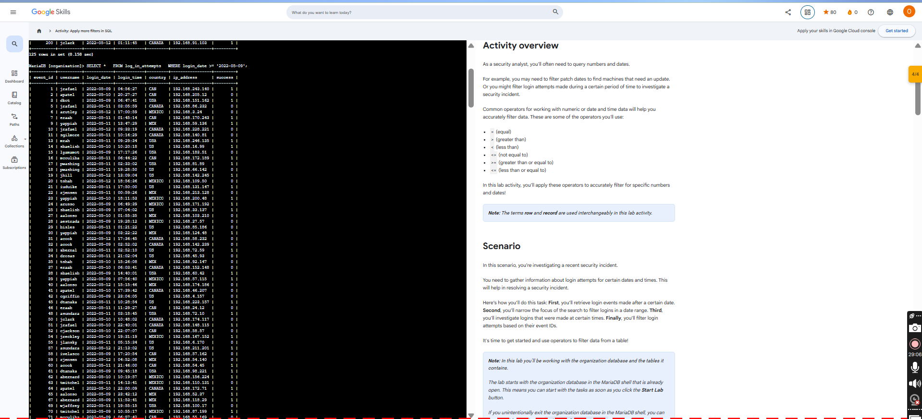

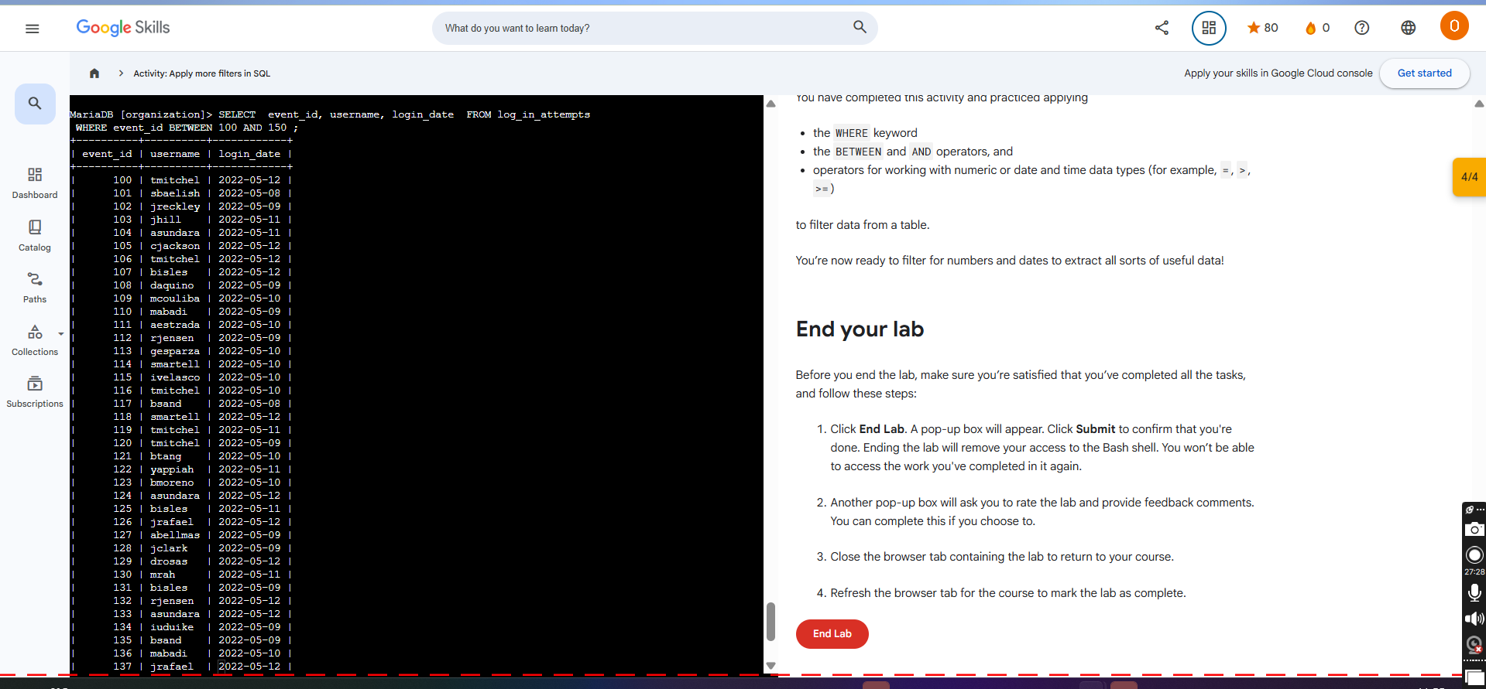

Filters with AND, OR, and NOT
AND : both conditions must be met. First, AND is used to filter on two conditions. AND specifies that both conditions must be met simultaneously.
SELECT firstname, lastname, email, country, supportrepid
FROM customers
WHERE supportrepid = 5 AND country = 'USA';

OR : Either conditions can be met. The OR operator also connects two conditions, but OR specifies that either condition can be met. It returns results where the first condition, the second condition, or both are met.
SELECT firstname, lastname, email, country
FROM customers
WHERE country = 'Canada' OR country = 'USA';

Note: Even if both conditions are based on the same column, you need to write out both full conditions. For instance, the query in the previous example contains the filter WHERE country = 'Canada' OR country = 'USA
NOT: Unlike the previous two operators, the NOT operator only works on a single condition, and not on multiple ones. The NOT operator negates a condition. This means that SQL returns all records that don’t match the condition specified in the query.
SELECT firstname, lastname, email, country
FROM customers
WHERE NOT country = 'USA';

Combining logical operators
Logical operators can be combined in filters. For example, if you know that both the USA and Canada are not affected by a cybersecurity issue, you can combine operators to return customers in all countries besides these two. In the following query, NOT is placed before the first condition, it's joined to a second condition with AND, and then NOT is also placed before that second condition.
SELECT firstname, lastname, email, country
FROM customers
WHERE NOT country = 'Canada' AND NOT country = 'USA';

Practical Lab
-- Retrieve all failed login attempts that occurred after business hours (after 18:00)
SELECT *
FROM log_in_attempts
WHERE login_time > '18:00' AND success = FALSE;

-- Retrieve all login attempts that occurred on May 8, 2022 or May 9, 2022
SELECT *
FROM log_in_attempts
WHERE login_date = '2022-05-09' OR login_date = '2022-05-08';

-- Retrieve all login attempts that did not originate in Mexico
SELECT *
FROM log_in_attempts
WHERE NOT country LIKE 'MEX%';

-- Retrieve all employees in the Marketing department who are located in the East building
SELECT *
FROM employees
WHERE department = 'Marketing' AND office LIKE 'East%';

-- Retrieve all employees who work in either the Finance or Sales department
SELECT *
FROM employees
WHERE department = 'Finance' OR department = 'Sales';

-- Retrieve all employees who are not in the Information Technology department
SELECT *
FROM employees
WHERE NOT department = 'Information Technology';

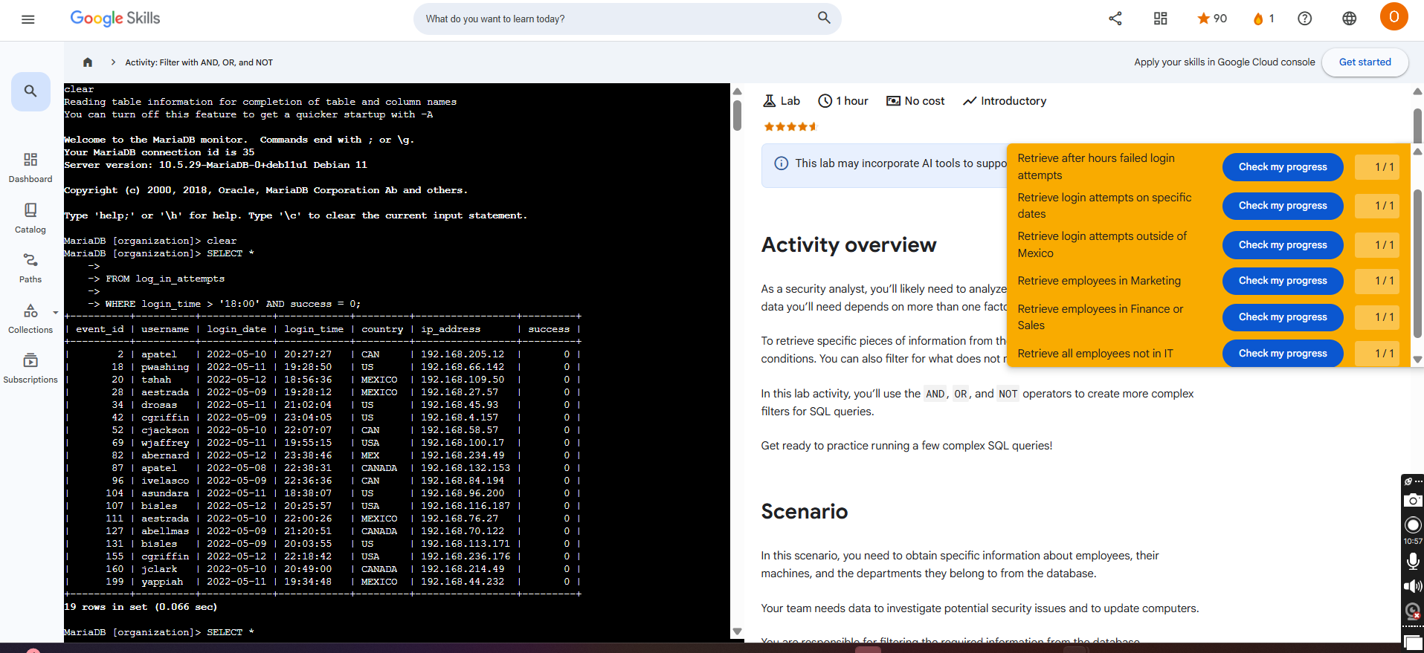

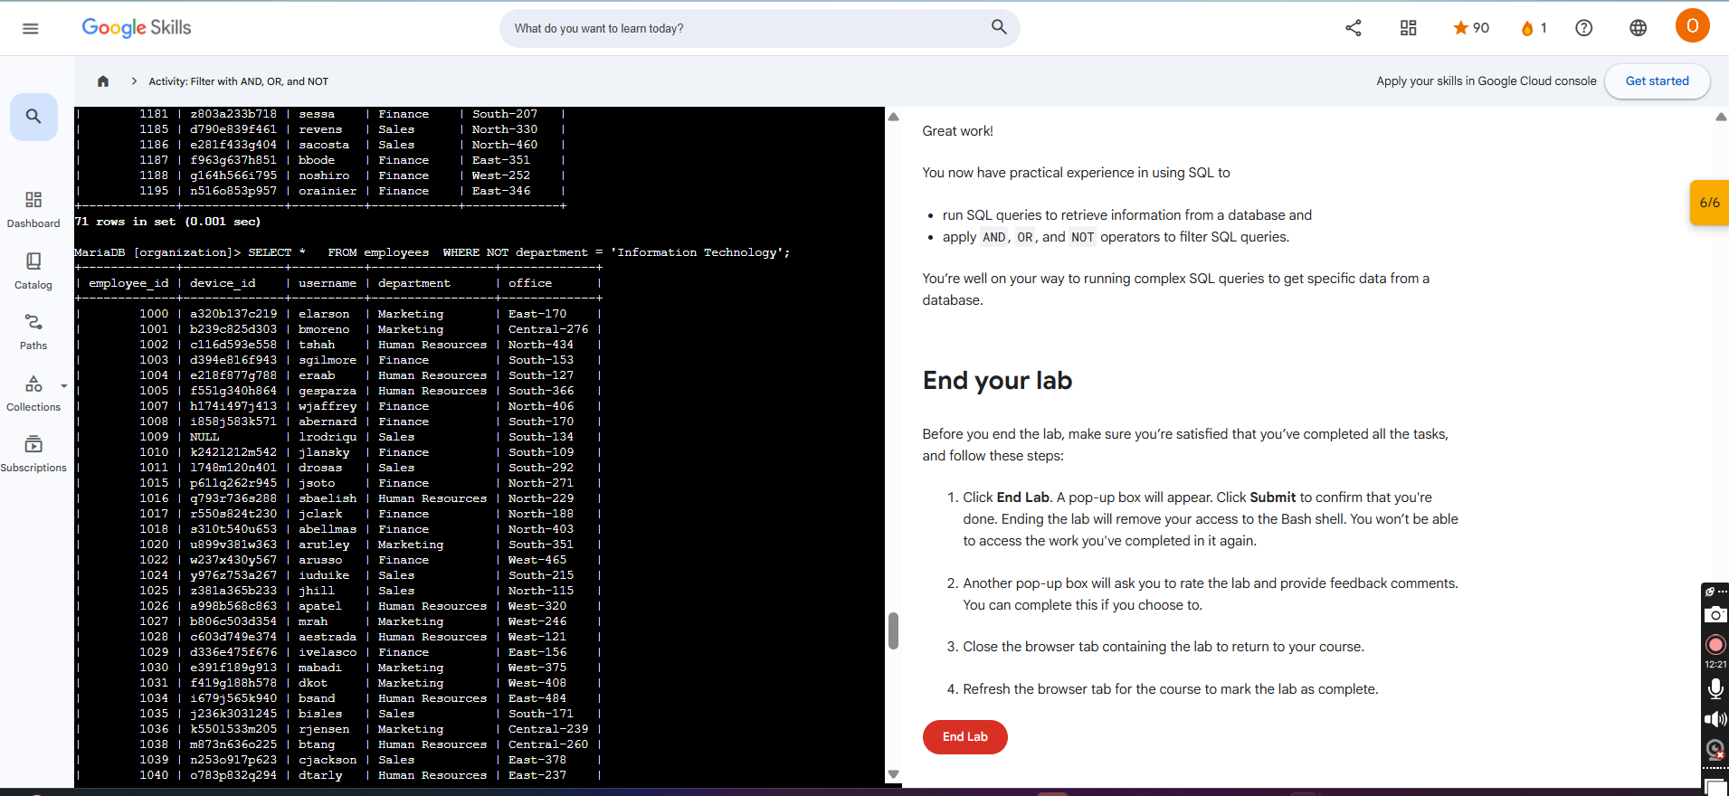

Joining in SQL

Code
-- Question 1: Retrieve all records from the machines table to review available machine data.
SELECT *
FROM machines;
-- Question 2: Use an INNER JOIN to identify which employees are using which machines
-- by matching records on the shared device_id column.
SELECT *
FROM machines
INNER JOIN employees
ON machines.device_id = employees.device_id;
-- Question 3: Use a LEFT JOIN to return all machines and any employees assigned to them,
-- including machines that are not assigned to any employee.
SELECT *
FROM machines
LEFT JOIN employees
ON machines.device_id = employees.device_id;
-- Question 4: Use a RIGHT JOIN to return all employees and any machines assigned to them,
-- including employees who do not have a machine assigned.
SELECT *
FROM machines
RIGHT JOIN employees
ON machines.device_id = employees.device_id;
-- Question 5: Use an INNER JOIN to retrieve all login attempts made by employees
-- by joining the employees and log_in_attempts tables on the username column.
SELECT *
FROM employees
INNER JOIN log_in_attempts
ON employees.username = log_in_attempts.username;

Other functions in SQL

Aggregate functions
In SQL, aggregate functions are functions that perform a calculation over multiple data points and return the result of the calculation. The actual data is not returned.
There are various aggregate functions that perform different calculations:
- COUNT returns a single number that represents the number of rows returned from your query.
- AVG returns a single number that represents the average of the numerical data in a column.
- SUM returns a single number that represents the sum of the numerical data in a column.

Aggregate function syntax
To use an aggregate function, place the keyword for it after the SELECT keyword, and then in parentheses, indicate the column you want to perform the calculation on. Eg:
SELECT COUNT(firstname)
FROM customers;
If you want to find the number of customers from a specific country, you can add a filter to your query:
SELECT COUNT(firstname)
FROM customers
WHERE country = 'USA';

